Who is this program for?  This camp is focused on girls ages 8-14.  What is the time frame?  Weekly, weekend sessions run 1.5 hrs. over an 8 week period.  What is Horsemanship Camp?  Girl Power employs EAL (Equine Assisted Learning) through horse facilitated exercises (non-mounted) to build confidence & self-esteem in a group setting.  EAL promotes life skills for personal, professional and educational goals. Horsemanship camp is also a great stepping stone for those girls who would like to move on to riding lessons.  What could be more fun than learning about yourself and valuable life skills while working with horses? | Summit Centre provides camps, clinics and riding lessons for a diverse clientele. Through EAL (Equine Assisted Learning), our Horsemanship camps provide personalized, non-mounted exercises that encourage personal growth. Our horses are facilitators for this learning.  Check out our website for more information on programs and services we offer:  www.summitcentre4TR.com  Contact Us  Phone:  302.690.7235  Email:  SummitCentre@outlook.com  Facebook:  Summit Center for Therapeutic Riding | SuMMit Centre  Girl Power  Horsemanship Camp  SuMmit centre
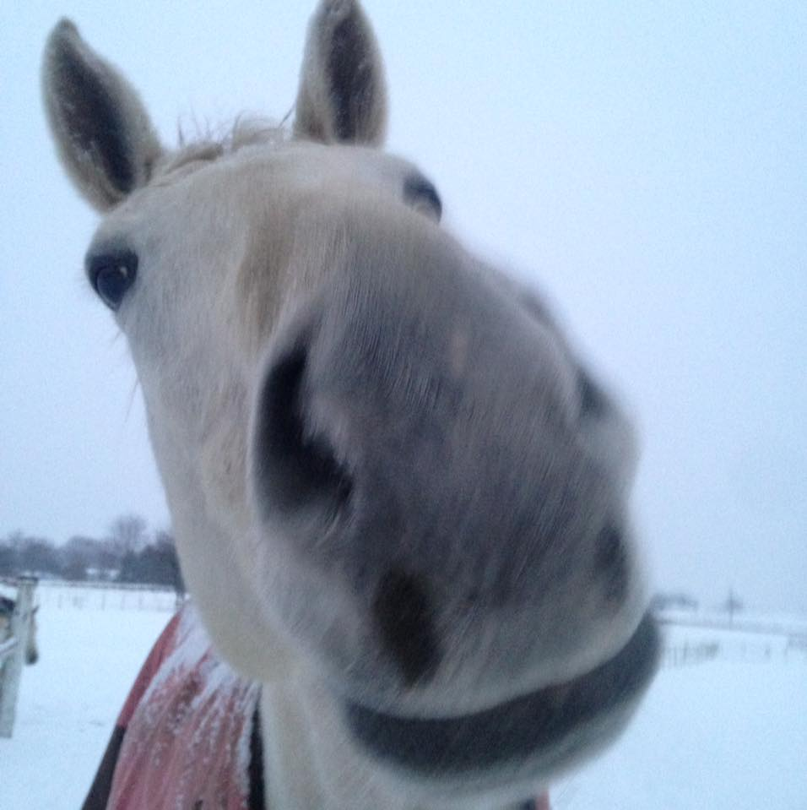  Lottie Mae is always up for some laughs!  Camp Mission  Through these workshops, we encourage independence, individualism and respect using positive support that fosters growth and self-esteem.  Camp Location  Our beautiful facility is located in Middletown Delaware on Rt. 15, only 5 miles from the Summit Bridge. We offer an indoor for bad weather and several outside rings to work in. Visit our website for photos. | Building Life Skills  This eight week, fun packed session uses our horses as a catalyst for change and understanding of these important life skills;  - Confidence  - Self-esteem  - Conflict Resolution  - Leadership Skills  - Relationship Building  - Effective Communication  - Team Building  …all while working with horses!  Check out our Website:  www.summitcentre4TR.com  Send us an email:  SummitCentre@outlook.com | 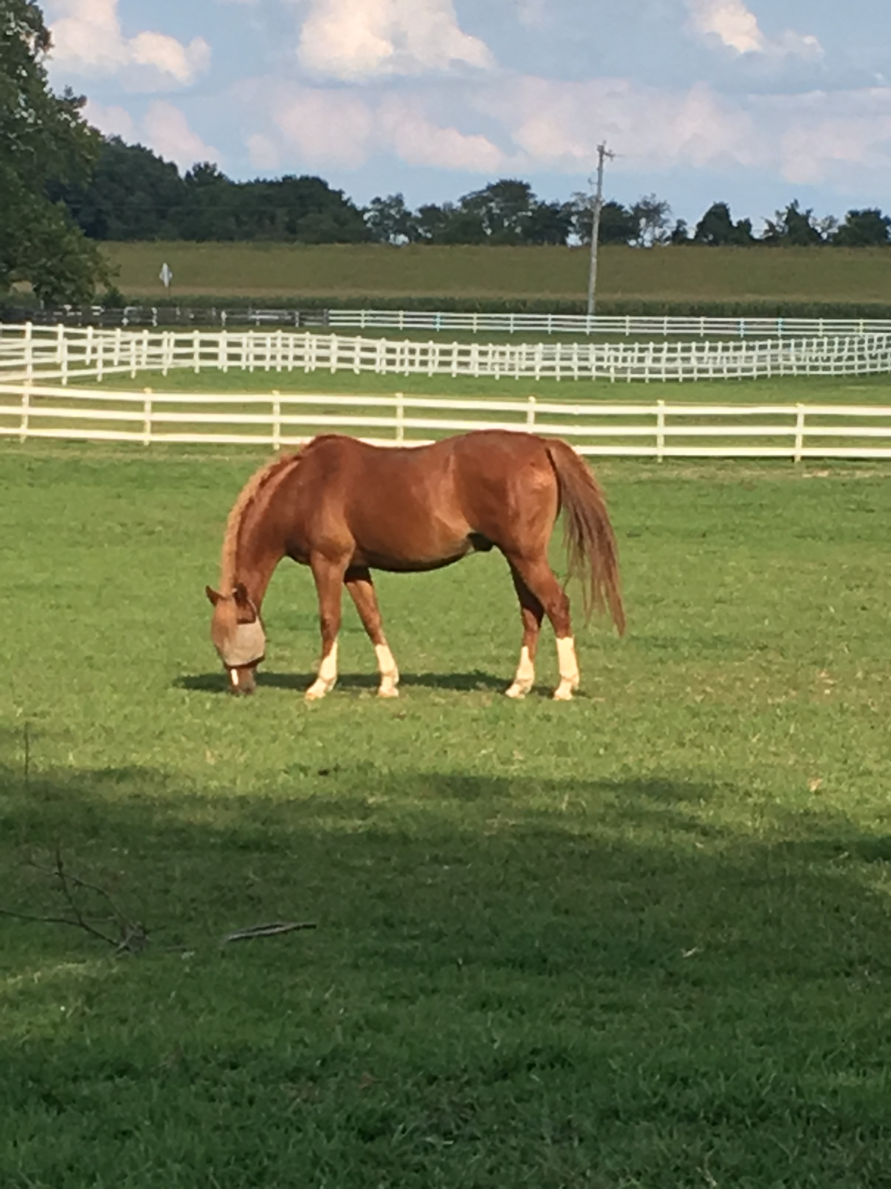  How would you like to work with Pony  Why uses horses?  Horses are some of life’s best teachers and healers. They are extremely intuitive, non-judgmental and have the ability to mirror our behavior and feelings.  “In their eyes shine stars of wisdom and courage to guide men to the skys.  Jodie Mitchell  Call Us:  302.690.7235

